**Code:**

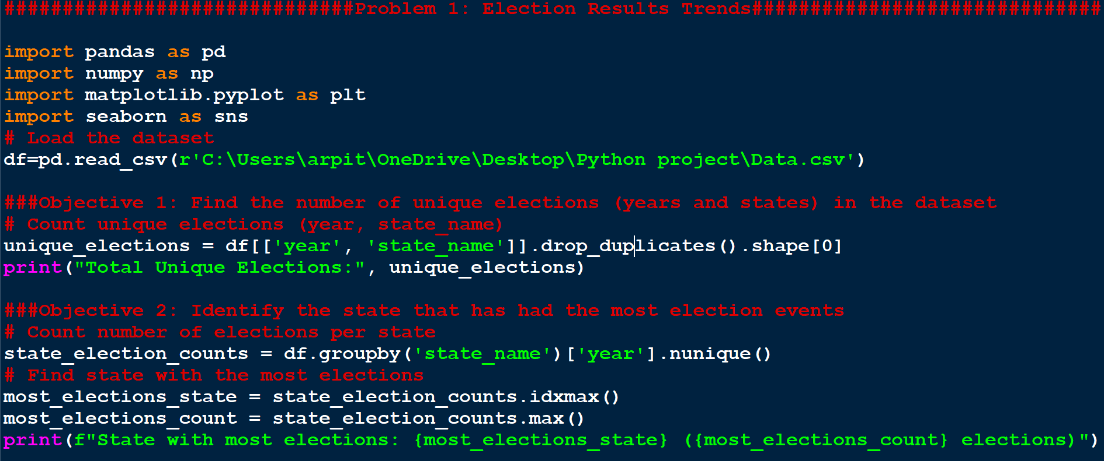

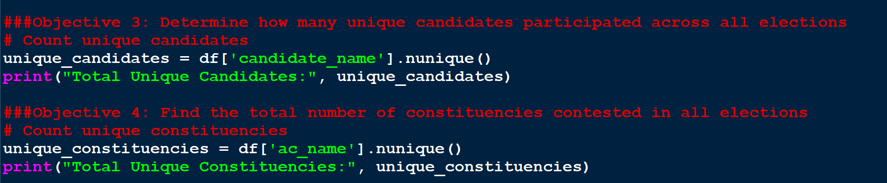

##############################Problem 1: Election Results Trends##############################

import pandas as pd

import numpy as np

import matplotlib.pyplot as plt

import seaborn as sns

# Load the dataset

df=pd.read_csv(r'C:\Users\arpit\OneDrive\Desktop\Python project\Data.csv')

###Objective 1: Find the number of unique elections (years and states) in the dataset

# Count unique elections (year, state_name)

unique_elections = df[['year', 'state_name']].drop_duplicates().shape[0]

print("Total Unique Elections:", unique_elections)

###Objective 2: Identify the state that has had the most election events

# Count number of elections per state

state_election_counts = df.groupby('state_name')['year'].nunique()

# Find state with the most elections

most_elections_state = state_election_counts.idxmax()

most_elections_count = state_election_counts.max()

print(f"State with most elections: {most_elections_state} ({most_elections_count} elections)")

###Objective 3: Determine how many unique candidates participated across all elections

# Count unique candidates

unique_candidates = df['candidate_name'].nunique()

print("Total Unique Candidates:", unique_candidates)

###Objective 4: Find the total number of constituencies contested in all elections

# Count unique constituencies

unique_constituencies = df['ac_name'].nunique()

print("Total Unique Constituencies:", unique_constituencies)

**Output:**

